von https://www.washingtonpost.com/graphics/politics/2016-election/trump-charts/?

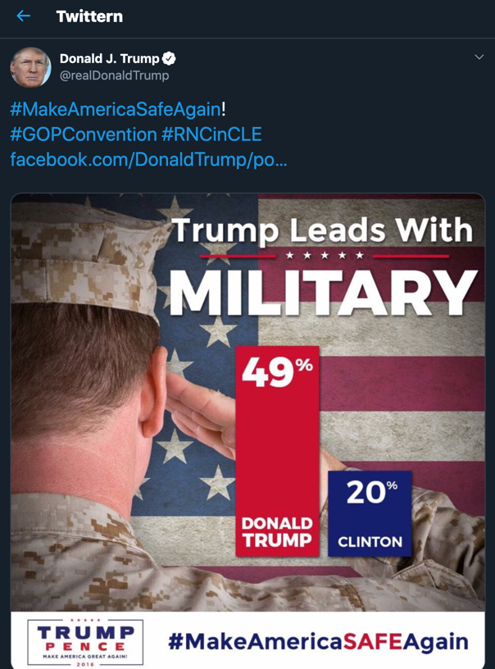

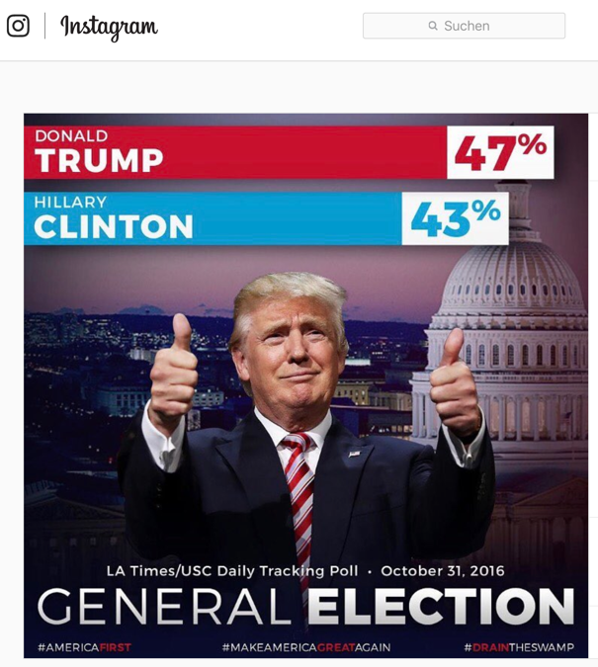
https://www.instagram.com/p/BMPKtZ2DLxa/

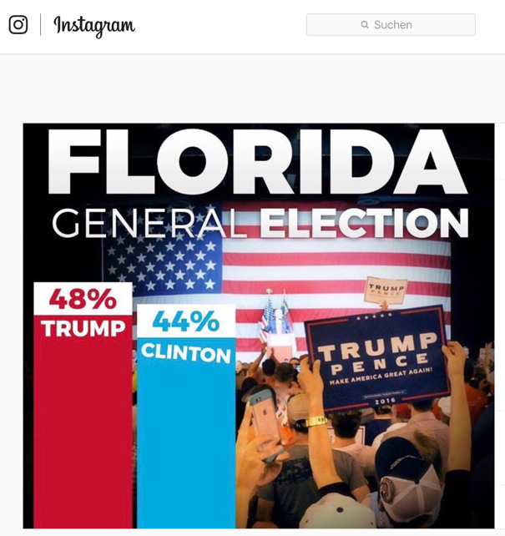
https://www.instagram.com/p/BMPKlmcje-u/

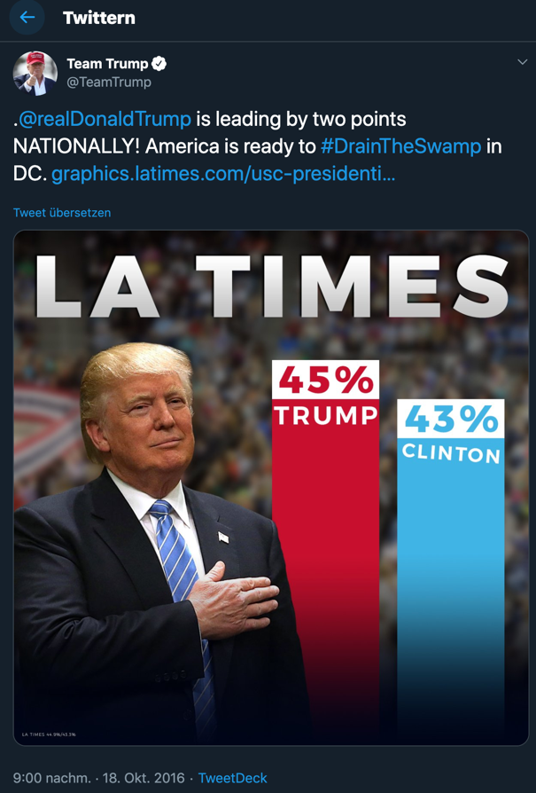
https://twitter.com/TeamTrump/status/788454619106021376

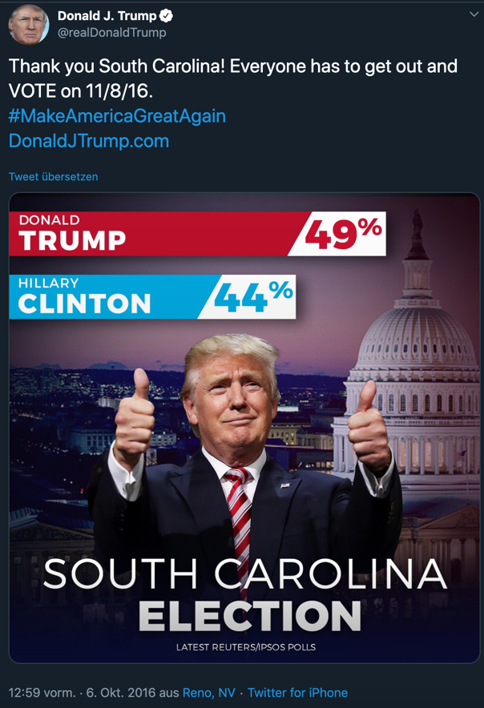
https://twitter.com/realDonaldTrump/status/783803924050350080

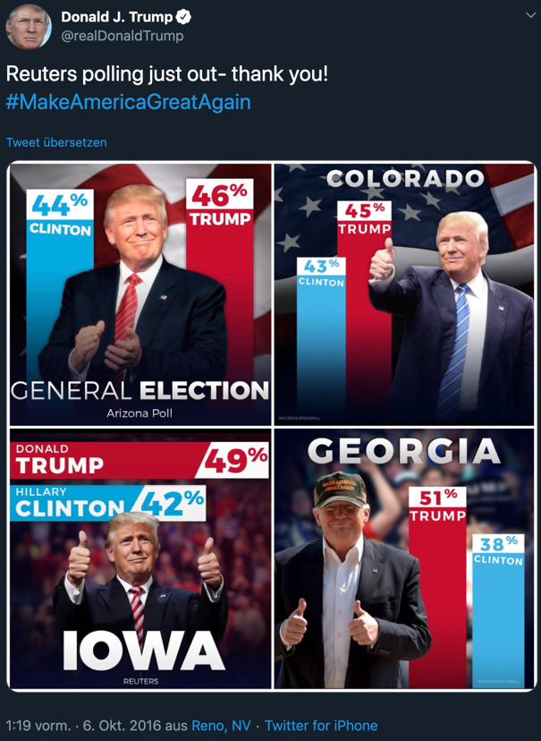
https://twitter.com/realDonaldTrump/status/783808918824681472

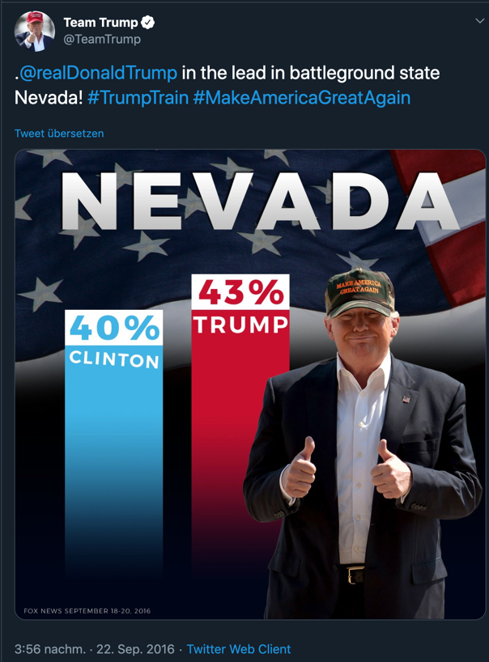
https://twitter.com/TeamTrump/status/778956014360166401

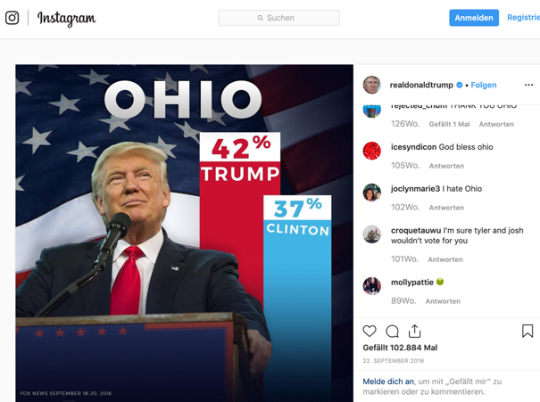
https://www.instagram.com/p/BKqYtLYDnBa/

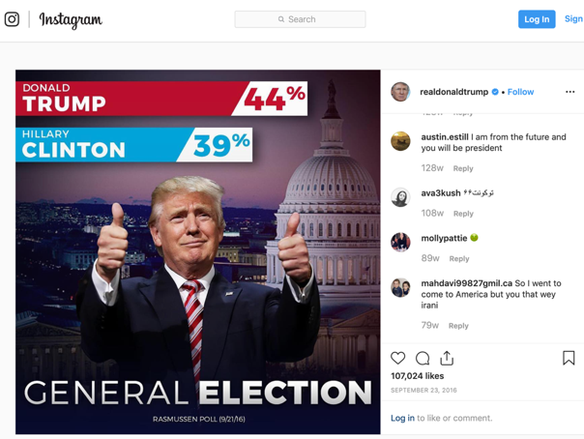
https://www.instagram.com/p/BKrLqISjnkm/?hl=en

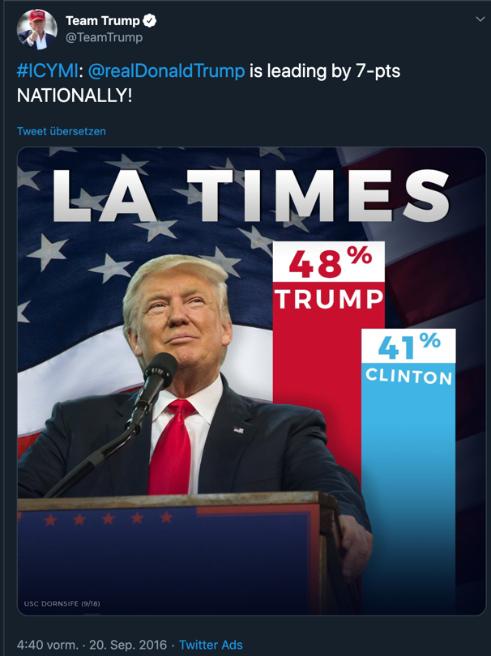
https://twitter.com/TeamTrump/status/778061141507321856

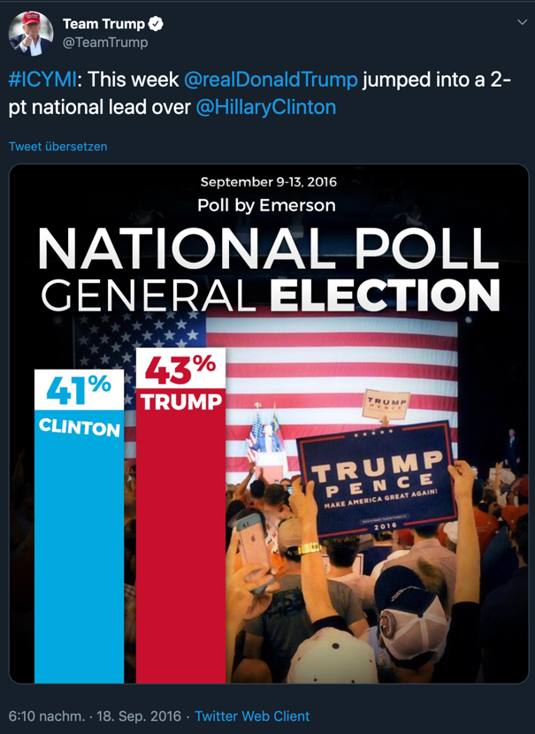
https://twitter.com/TeamTrump/status/777540363670155271

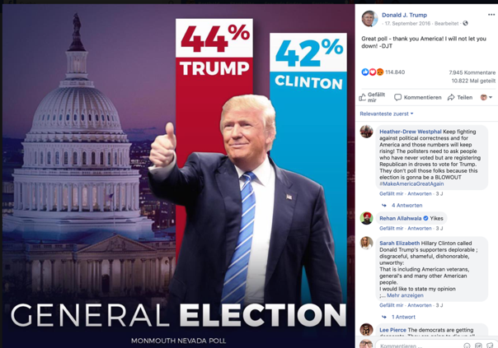
https://www.facebook.com/DonaldTrump/photos/a.488852220724/10157707883725725/?type=3&theater

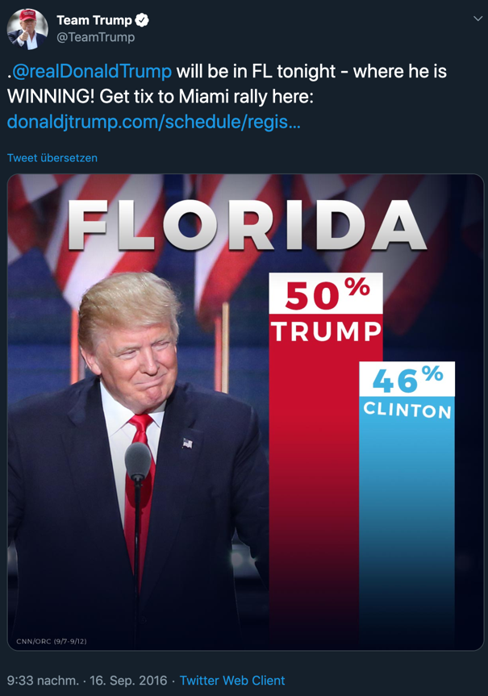
https://twitter.com/TeamTrump/status/776866520030937088

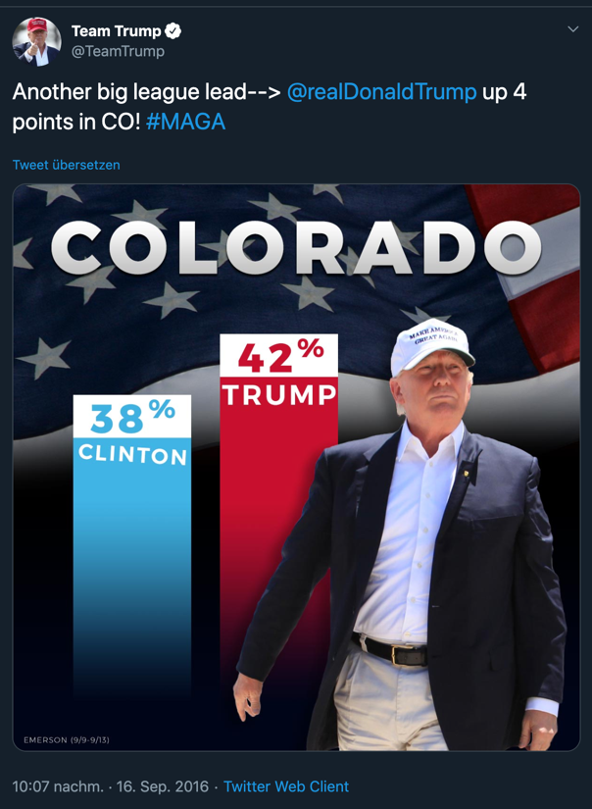
https://twitter.com/TeamTrump/status/776875054936317953

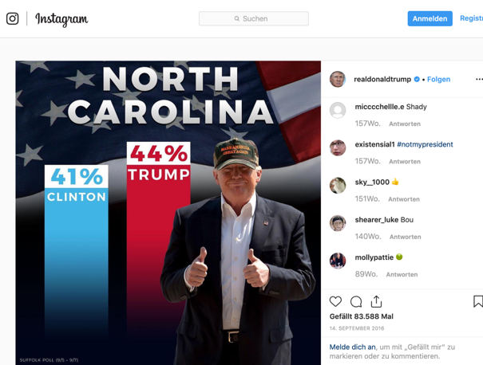
https://www.instagram.com/p/BKVtvPojtXc/

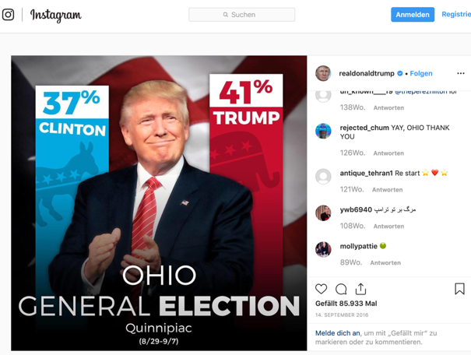
https://www.instagram.com/p/BKVty7zD9M2/

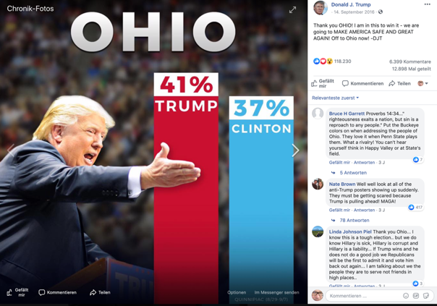
https://www.facebook.com/DonaldTrump/photos/a.488852220724/10157693430930725/?type=3&theater

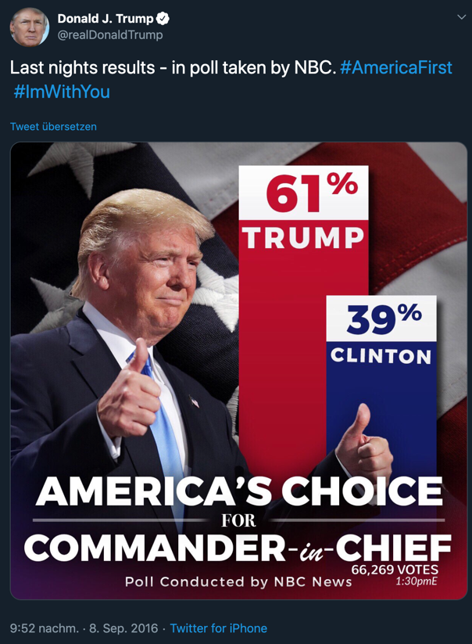
https://twitter.com/realDonaldTrump/status/773972305642913792

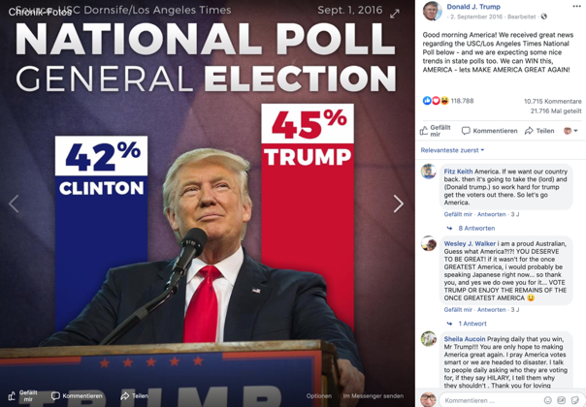
https://www.facebook.com/DonaldTrump/photos/a.488852220724/10157616391995725/?type=3&theater

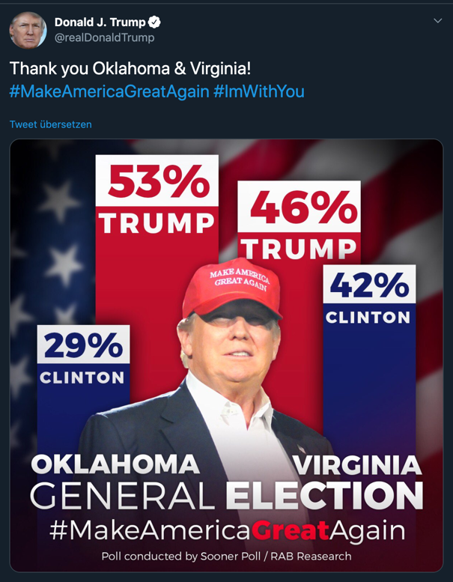
https://twitter.com/realDonaldTrump/status/760213628926779392

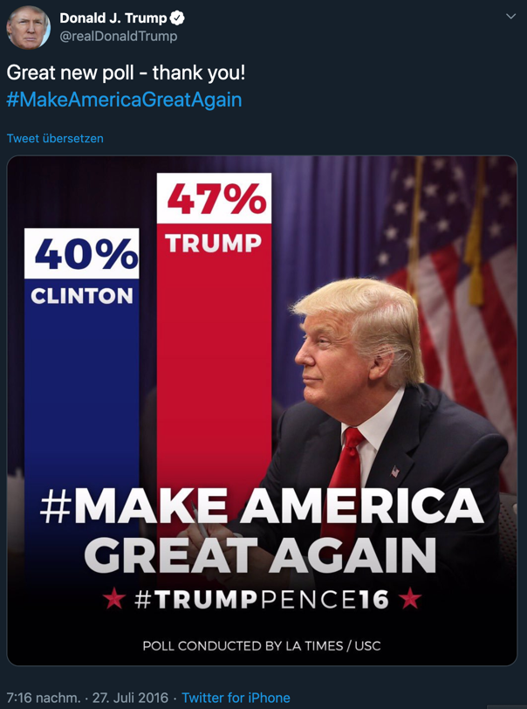
https://twitter.com/realDonaldTrump/status/758350470402408449

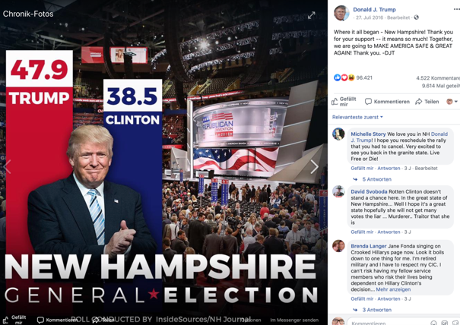
https://www.facebook.com/DonaldTrump/photos/a.488852220724/10157375935840725/?type=3&theater

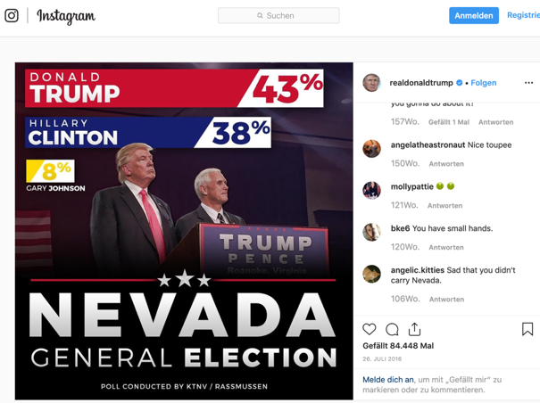
https://www.instagram.com/p/BIVN8_uDXx0/

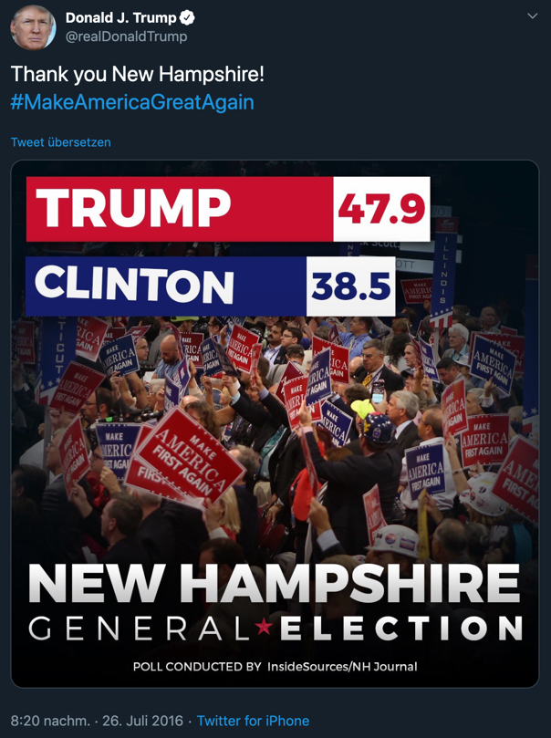
https://twitter.com/realDonaldTrump/status/758004154417553409

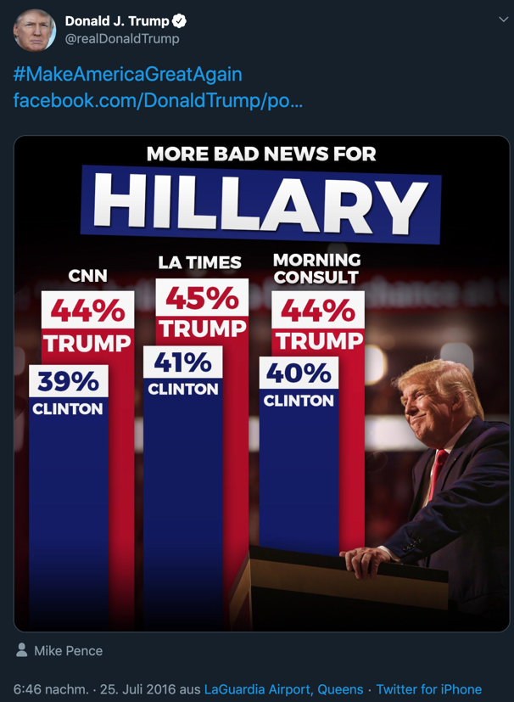
https://twitter.com/realDonaldTrump/status/757618048664829952

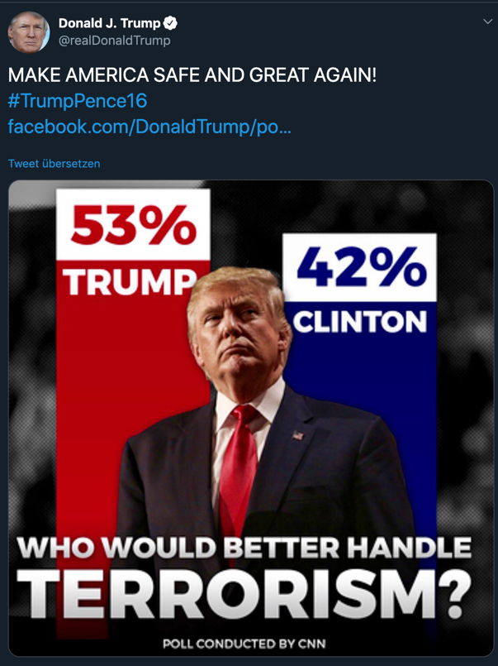
https://twitter.com/realDonaldTrump/status/757650904896139264

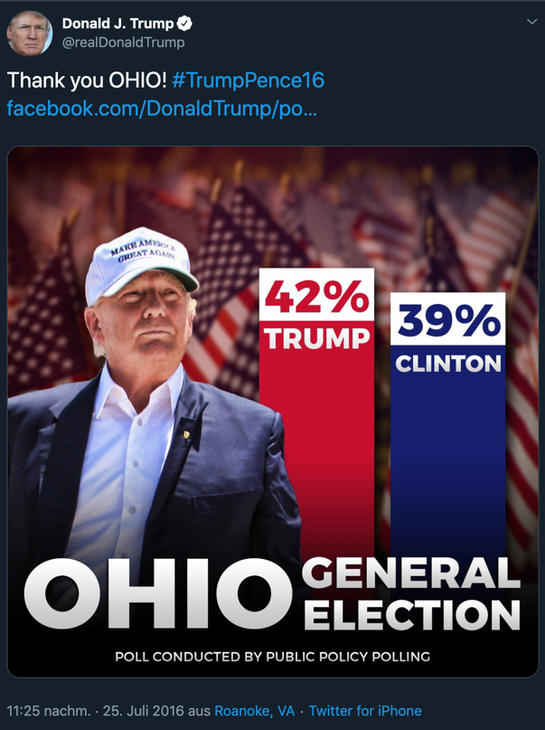
https://twitter.com/realDonaldTrump/status/757688331597668353

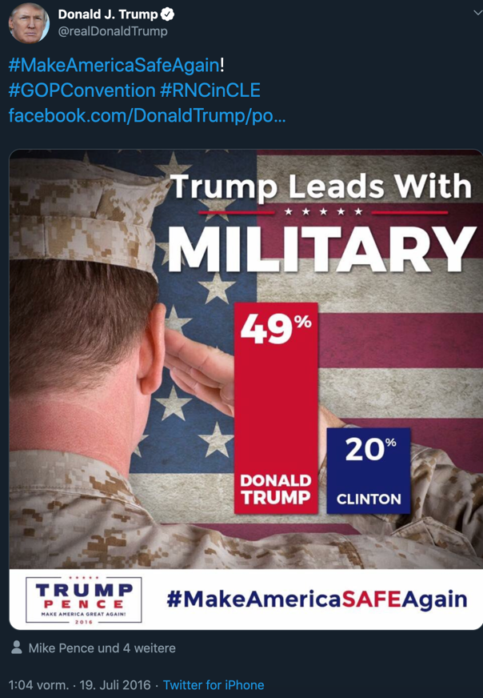
https://twitter.com/realDonaldTrump/status/755176368783187969

